A000-Afr-Nigeria-Yoruba-Ceremonial Bell-mid 20th c

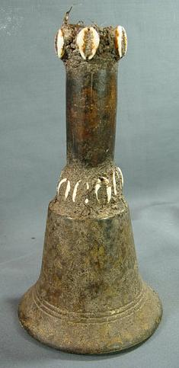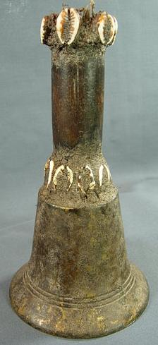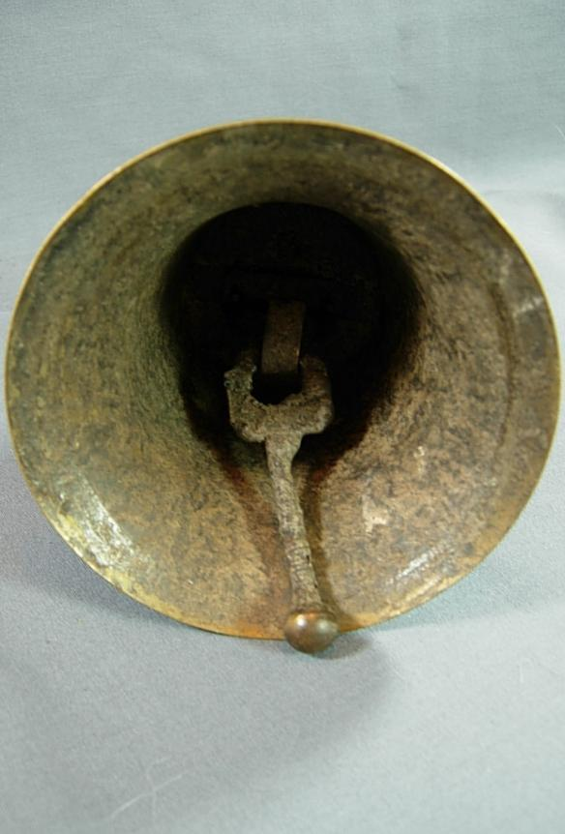

Figs. 1-3. Afr-Nigeria-Yoruba-Ceremonial Bell-mid 20th c

Case No.: 6

**Accession No.**

**Formal Label:** Afr-Nigeria-Yoruba-Ceremonial Bell-mid 20th c

**Display Description:**

Within the Yoruba religion, many ceremonies are concerned with offerings that are made to the Orisha (Gods). Before any offerings are made, the priest/priestess or Oba/Babalawo will ring the ceremonial bell to communicate with the Orisha who will be entreated to receive the offering. This bronze bell is embedded with cowrie shells that suggest a fruitful outcome. This bell appears to have had feathers on top which are no longer. Blood stains were found, which are signs of sacrificial libations.

**LC Classification:**

**Date or Time Horizon:**

**Geographical Area:**

**Map:**

**GPS coordinates:**

**Cultural Affiliation:**

**Media: bronze, wood, cowrie shells**

**Dimensions: 8" at height, 4 1/2" mouth diameter**

**Weight:**

**Condition:**

**Provenance:**

**Discussion:**

**References:**